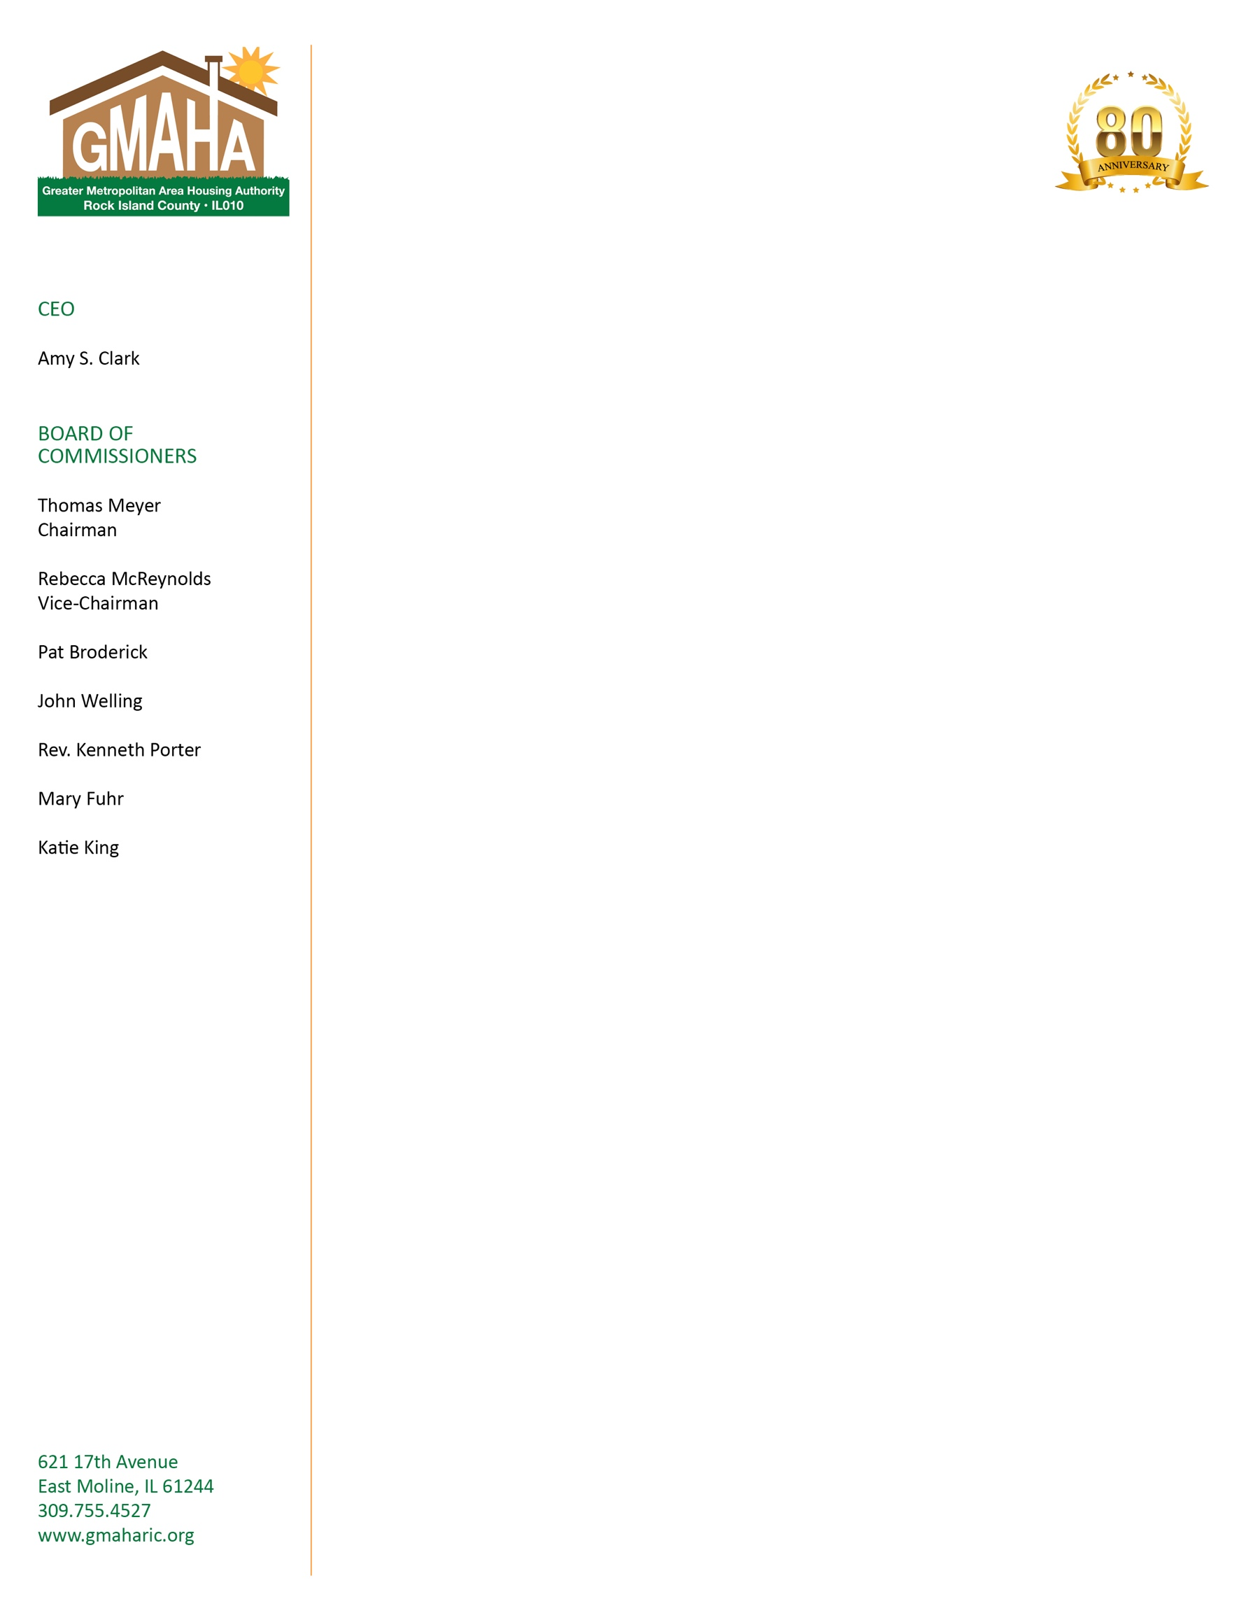

**NOTICE OF PUBLIC REVIEW**

**OF AGENCY PLAN 2020**

The Greater Metropolitan Area Housing Authority of Rock Island County

has developed its Annual 2020 Agency Plan in compliance with the Quality Housing and Work Responsibility Act of 1988. It is available for review at the Housing Authority's Main Office located at 621 Seventeenth Avenue, East Moline, IL 61244-2036. The Authority's hours of operation are M-F, 8:00 AM-4:00 PM. A public hearing will be held on Wednesday, December 11, 2019, 9:00 AM at the same location.

**EOH**